# AIAC 7.2 ASSIGNMENT

K. CHANDRIKAA

2403A51227

B-10

**TASK 1:** Task #1 – Syntax Error in Conditionals

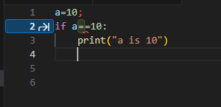

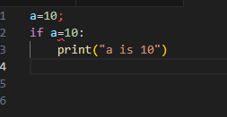

**copilot suggested a correction that ‘=’ isn’t right to compare and it should be ‘==’.**

**SYNTAX ERROR**

**TASK 2:** Task #2 – Loop Off-By-One Error.

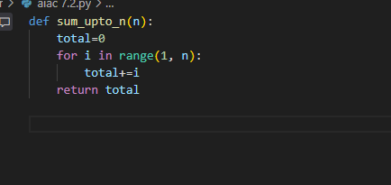

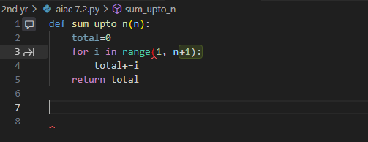

**copilot corrects the code by suggesting n+1 instead of n for sum**

**LOGICAL ERROR**

**TASK 3:** Error: AttributeError

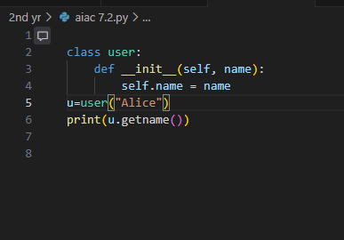

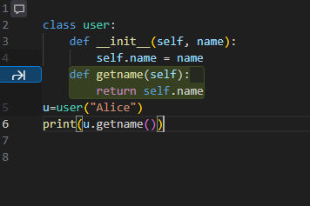

**Here the error is the method that was called is missing in the code and copilot fixed it by giving an inline suggestion**

**TASK 4:**

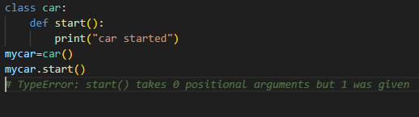

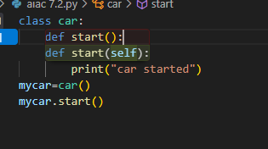

**Here the error was not giving any parameters in start function and co-pilot fixed it by an inline suggestion**

**Incorrect Class Attribute Initialization**

**TASK 5: LOGIC ERROR**

